03.04.2019

MEANS OF TRANSPORT

Travel BY …

Google “CRAZY TRANSPORTS” – pair work:
pick up a photo, describe it and see if your partner can recognize it!

WEIRD

Wheel = ruota
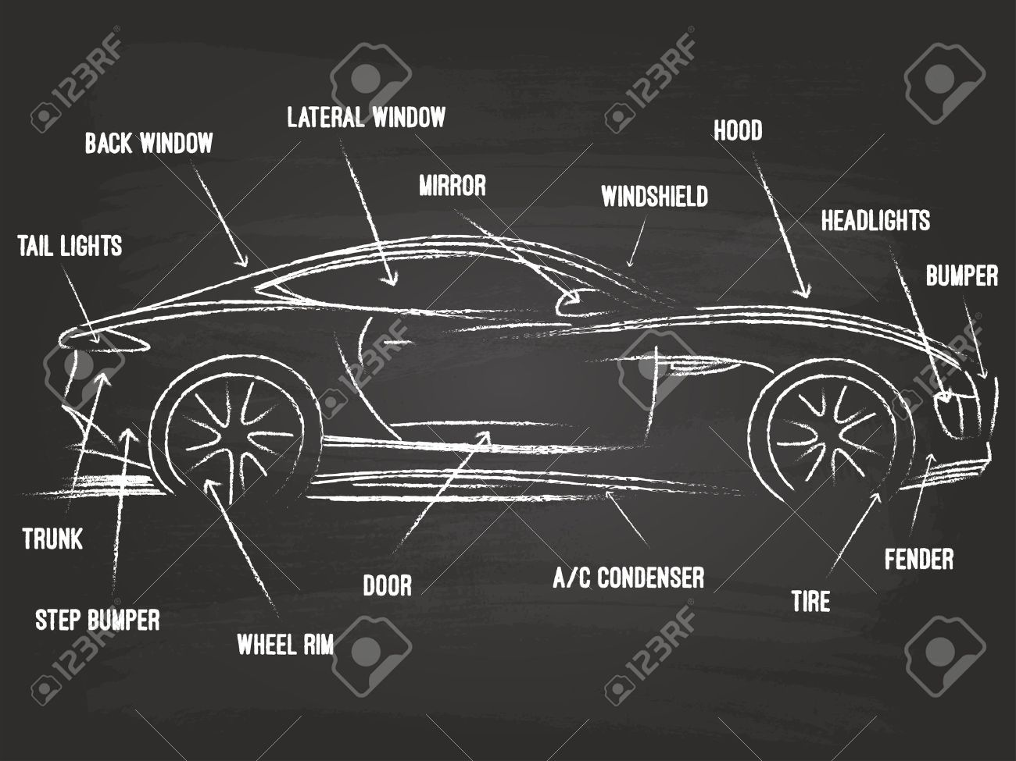
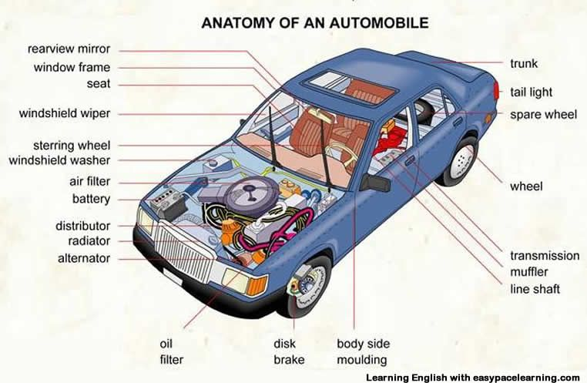

Da quanto tempo sai andare in bici?
CAN??? – il present perfect di CAN non esiste!
LEARN??? Non va bene

- How long have you known how to ride a bike?

Kick scooter (push scooter) 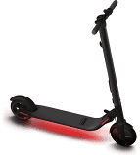

Overboard

Snowmobile 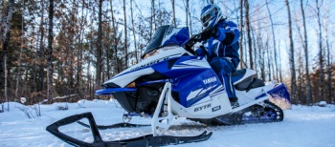

Go on a CRUISE.
Go on holiday/vacation.
Go on a school trip.

https://www.slideshare.net/miculoistaken/trinity-grade-5-means-of-transports-16231740
most difficult question ?

POLLUTION = inquinamento
To POLLUTE = inquinare
CO2 emissions (Carbon Dioxide)
FUEL – petrol/gas

Other questions:
- What is the most convenient means of transport in Milan?
- What is the most comfortable means of transport you have ever used?
- Which means of transport would you like to drive?
- What age should you be to drive a car in Italy?

Driving licence - to get a driving license
To pass an examination

Colour – color
Recognise – recognize

