LAZIO: THE CAPITAL REGION

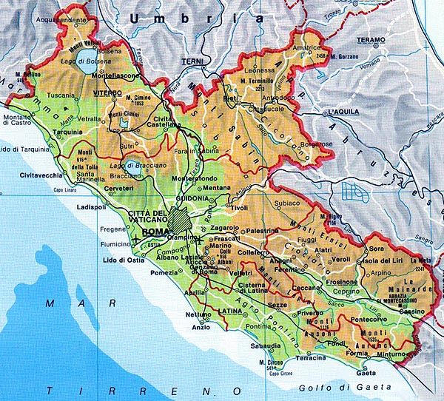

GEOGRAPHY
Lazio is bordered by Tuscany, Umbria, and Marche to the north, Abruzzo and Molise to the east, Campania to the south, and by the Tyrrhenian Sea to the west.
The region is mostly composed by hills, like the Maremmana flat land and the Tevere Valley. The region it’s also composed by a lot of mountains. The most famous mountains are the Volsini, Cimini and the Sabatini mountains.
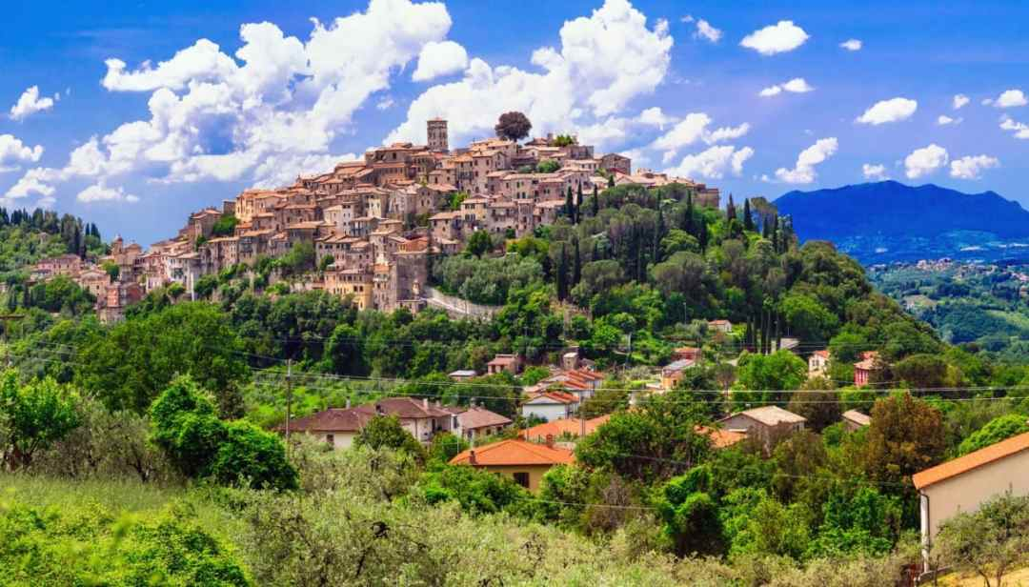
There are also a lot of lakes, like the Bolsena lake, Vico lake, Bracciano lake, Albano lake and Nemo lake.
The Lazio coast is very regular, low and sandy; despite this there are some "protrusions", such as Capo Linaro south of Civitavecchia, the mouth of the Tevere between the cities of Rome and Fiumicino.
At the south of the river there are in succession the promontory of Anzio and Nettuno, the Monte Circeo and the promontory of Gaeta, near the border with Campania.
The most famous river is the Tevere, that comes from Umbria. There are also the Sacco river, the Liri-Garigliano river, the Marta, the Arrone and the Fiora river.
Tourist attractions

Lazio is a treasure chest of elegant and historical cities, such as Rome, Viterbo, Latina, Rieti and Frosinone.

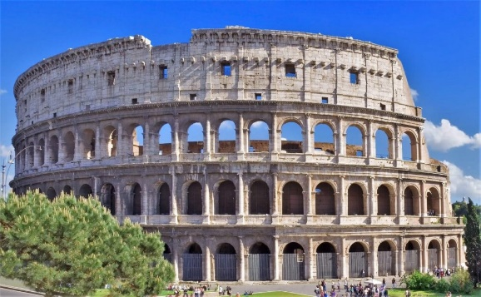 The symbol of the region is the Colosseum, known also as Flavian Amphitheater. The Colosseum is the biggest amphiteater of the world. It was built by the emperators Vespasiano and Tito. In ancient times it was used for gladiatorial shows and other public events.

There is also the Pantheon, a majestic monument built for the gods 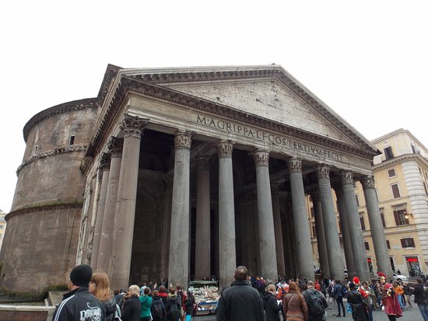 of the past, and the Vittoriano, an enormous building built in honor of Vittorio Emanuele II.
Another pearl of the “eternal city” are the Vatican Museums, full of masterpieces made by glorious artists like Michelangelo, Raffaello, Leonardo and Caravaggio. The main attraction of these museums is the Sistine Chapel by Michelangelo.
In Sistine Chapel you are surrounded by Michelangelo’s frescos, like the glorious “Giudizio Universale”, considered as the most famous and important work by Michelangelo.

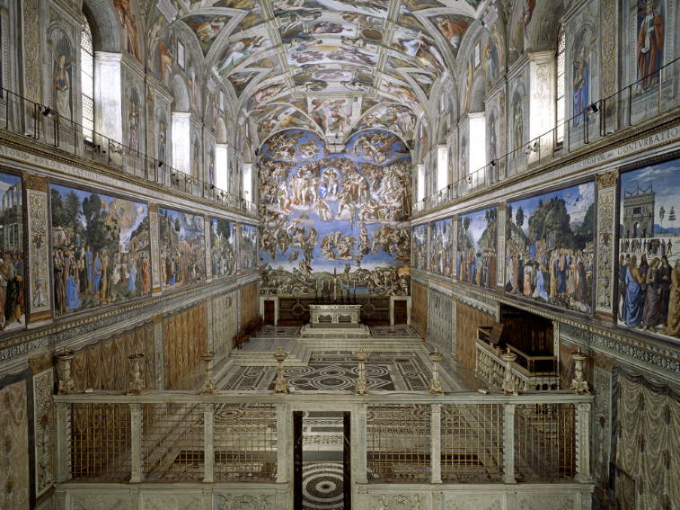

At the religious level, Rome is the main city in the world of the Catholic religion, with the highest concentration of churches and basilicas of various historical periods, from the 4th century until today. Among the most famous are the Cathedral of San Giovanni in Laterano, and the papal basilicas of San Giovanni in Laterano, St. Peter's in the Vatican, Santa Maria Maggiore, St. Paul's Fuori Le Mura ; together with other basilicas like the Basilica of San Lorenzo outside the walls, the Basilica of Santa Maria in Araceli and many others. Also the catacombs are of visual and cultural impact, such as the catacombs of San Callisto, burial place of martyrs, popes and of artistic importance for the wall paintings.

The most famous buildings are Palazzo Senatorio on the Campidoglio, the Palazzo Farnese, the Palazzo Colonna, the Palazzo Barberini, the Palazzo del Quirinale, the Palazzo Madama, the Palazzo Montecitorio.
There are also the green areas of Villa Borghese, as well as to the numerous squares such as Piazza Fontana, Piazza Navona, Piazza Venezia with the Vittoriano, Piazza di Spagna and Piazza del Popolo.

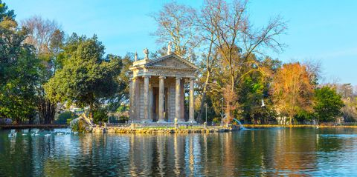

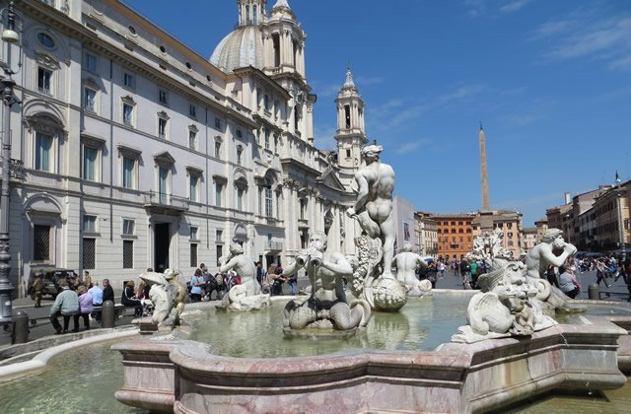
FOOD AND WINE

The cuisine is popular, based on strong and savory flavours typical of central Apennine Italy, with extensive use of the so-called “quinto quarto”.
The culinary personality of Rome has great weight, merged with more properly Mediterranean, southern and Tuscan influences, and Jewish and Kosher gastronomy, thanks to the presence of the Rome “ghetto”, the oldest in Rome.

The pasta dishes are very tasty and simple, the two most famous pasta dishes are the “Amatriciana”, that is a piquant sauce made by onions, pig check, pecorino cheese and tomato sauce, and the “Carbonara”, made by eggs, freshly ground black pepper, and Pecorino cheese.
There is also the Lamb, Roman style and also as a chop. It’s famous the veal escalope cooked with sage and Parma ham, called “Saltimbocca”. Particularly appreciated is the chicken roman style , also with peppers, and the chicken “Cesaretto”, stewed with tomatoes, vinegar and red chilli pepper.
Among the desserts are famous the “Maritozzi”, soft cream puffs filled with cream.
Another typical products from Lazio are the Pecorino D.O.P. , and the Mozzarella cheese, also produced in Lazio.
The most famous wines are the Castelli Romani, Cesanese del Piglio and Olevano, Colli Albani, Colli Sabini, and the Frascati.

TOP CHEFS AND RESTAURANTS

The most famous chefs are Anthony Genovese (“Il Pagliaccio” restaurant), that offer a sophisticated and elegant cuisine. Cristina Bowerman (“Glass” Restaurant) that serves light dishes and tasty wines.
There is also famous Heinz Beck (“La Pergola” restaurant), with a luxury cuisine and it’s, in the meantime, traditional and innovative.

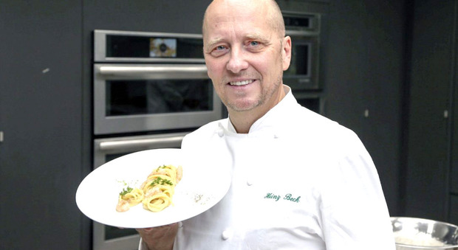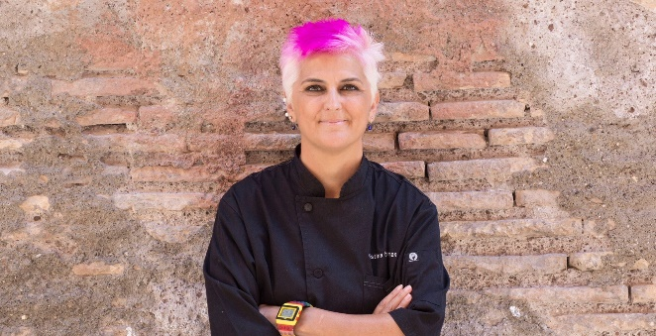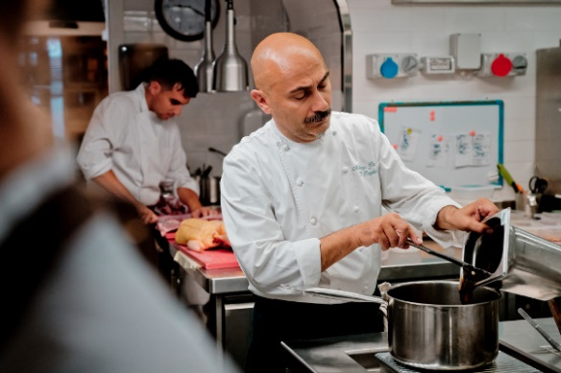

soccer

S.S. Lazio is an Italian professional soccer team based in Rome.
Lazio have been Italian champions twice (1974, 2000), and have won the Coppa Italia six times, the Supercoppa Italiana four times, and both the UEFA Cup Winners' Cup and UEFA Super Cup on one occasion.

A.S. Roma have won Serie A three times, in 1941–42, 1982–83 and 2000–01, as well as winning nine Coppa Italia titles and two Supercoppa Italiana titles. In European competitions, Roma won the Inter-Cities Fairs Cup in 1960–61 and were runners-up in the 1983–84 European Cup and the 1990–91 UEFA Cup.

Since 1953, Roma have played their home matches at the Stadio Olimpico, a venue they share with city rivals Lazio. With a capacity of over 72,000, it is the second-largest of its kind in Italy.

