Mole Antonelliana  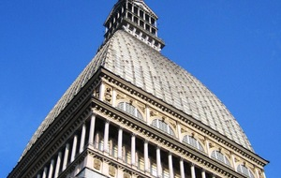  - Contact: +39 ( 0) 11 53 51 81  - http://www.museocinema.it/  - Via Montebello 20  Museum  Mon., Wed., Thu., Fri. and Sun. 9.00 - 20.00  Saturday 9.00 - 23.00  Tuesday Closed  Last admission one hour before closing time  Panoramic Lift  Mon., Wed., Thu., Fri. and Sun. 9.00 - 20.00  Saturday 9.00 - 23.00  Tuesday Closed  Last admission one hour before closing time.  Museum + Panoramic Lift  Admission fee € 14.00  Concessions € 11.00  university students under 26 years old, 65 and over; groups min. 15 persons with booking compulsory  Young people and schools € 8.00  6 to 18 years old, school groups  Free admission up to 5 years old, disabled visitors and assistant  This iconic building is in many ways Turin's Eiffel Tower, the symbol of Turin. A 167.5 metre landmark, originally planned as a synagogue by Alessandro Antonelli, it was the highest brick building in the world at the time of its completion and remains the tallest building in Turin. Damaged by a storm in 1953, the spire was rebuilt, following its collapse, in metal with a stone overlay. Today it is home to Italy's National Cinema Museum. | Palazzo Reale e Giardini Reali  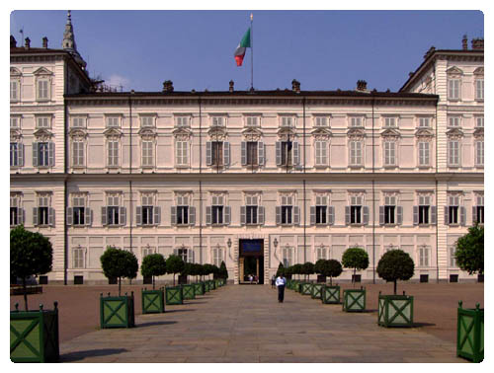  - Contact:  - 0039 (0) 11 43 61 455  - http://www.ilpalazzorealeditorino.it/  - Piazza Castello  On the north-eastern side of Piazza Castello, a little square can be seen. It is called the Piazzetta Reale, and is closed by a cast-iron gate topped by statues of the Dioscuri, twin brothers of Helen of Troy. On the far side of Piazza Reale is a view of the Royal Palace, residence of the Savoy family since 1865. It is possible to go on a guided tour through the various rooms where the rulers of the Savoy household once lived. The Royal Gardens are of particular interest, as they are situated behind the palace, and play host to various open-air bars and evening entertainment during the summer months.
Palatine Gate  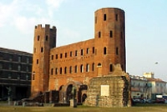 Piazza Cesare Augusto  Between the Piazza della Republica and Palazzo Reale sits the Porta Palatine, one of the four Roman city gates of Turin. Built around 25 BC, This was the Northern Gate and approaching from Via XX Settembre you can see the imposing twin towered gate rising up adjacent to the remains of the original Roman walls. It opened out onto the Cardo Maximus, the north south axis road, which terminated on the other side of the city at Porta Mamorea which was demolished in 1635. Between 1872 and 1934 restoration was undertaken to achieve the original appearance after centuries of structural additions and neglect. In 1724 the gate was used as a prison in 1877 as the City Music School. | 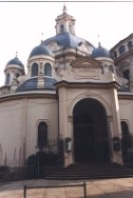Basilica della Consolata  - Contact: +39 011 483 6111  - http://www.laconsolata.org /  - Via Maria Adelaide  Construction on this church began in 1679 under Guarino Guarini. The foundations were laid on the site where the church of Saint Andrea previously stood with its hexagonal presbytery. After the death of Guarini, Juvarra designed the dome upon which Bortoloni's fresco was painted. The 11th century Romanesque tower belonged to the previous church and now sits on the right hand side of the Basilica's facade. The church is decorated with many valuable marbles, most of which were votive offerings. The impressive marble floor is one of the main talking points of this church. Next to the Basilica della Consolata stands a 25 meter high dedicatory column. A statue of the virgin Mary was placed on top in 1835 as a thank you to the Madonna for keeping at bay the dreaded plague which devastated Europe that year.
Caffè San Carlo 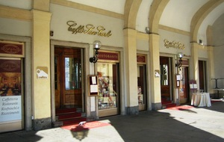  - Contact:  - +39 (0)11 53 25 86 http://caffesancarlo.it/ Piazza San Carlo, 156  Caffè San Carlo is one of Turin's oldest and most famous, in many ways, it is the essence of Turin's café culture, a place where you can have an espresso or prosecco in real style. Early chroniclers called it "a palace", hardly surprising as the lavish mixture of gilded mirrors, rich plasterwork and classical art is topped with a very large helping of Murano chandelier. In 1832 it became the first café in all of Italy to use gas lighting, which enhanced the interior, a favourite of Cavour and a place where the Risorgimento patriots met. Today its the perfect place to pause, reflect and people watch, whether in the morning to see the locals 'take' their heart starting espresso and enjoy a chocolate or cream pastry, or in the evenings when they return for free stuzzichini (almost all the cafés feature these evening snacks, if you pay for a drink you can help yourself to an aladdin's cave of pizzette, frittata, roated vegetables, salads, cheese, salami, olives, bread and more!) and an aperitivo. A Torinese 'must do' since 1822. | Cattedrale di San Giovanni Battista  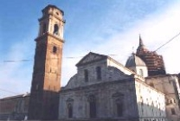  - Contact: +39 011 436 1540 http://www.comune.torino.it/chiese/sangio.htm  - Piazza San Giovanni  The controversial Shroud of Turin (Sacra Sindone) and the chapel in which it is enshrined every jubilee year, Cappella della Santa Sindone, hold pride of place in this otherwise uninteresting, pompous 15th-century church. Even without the presence of one of Christianity's most precious relics (and it's only rarely on view in the silver casket elevated on an altar in the center of the room), the chapel is well worth a visit. Still under construction after a 1997 fire (one of many the shroud has miraculously survived, with an occasional singeing, over the centuries), the chapel is somberly clad in black marble. But, as if to suggest that better things await us in the heavens, it ascends to an airy, light-flooded six-tiered dome, one of the masterpieces of Italian baroque architecture.  The shroud, of course, is allegedly the one in which the body of Christ was wrapped when taken from the cross -- and to which his image was miraculously affixed. The image is of a man 1.7m tall (5 ft., 7 in.), with bloodstains consistent with a crown of thorns, a cut in the ribcage, cuts in the wrists and ankles, and scourge marks on the back from flagellation. Recent carbon dating suggests that the shroud...
Santa Cristina  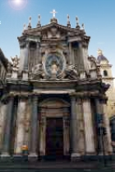  - Contact:  - +39 011 53 5181 (Tourist Information)  - Via Roma  - Piazza San Carlo  The church of Santa Cristina was built on the request of Madama Reale, Maria Cristina, in 1639 on the project of Carlo di Castellamonte. The facade erected between 1715 and 1718, is the work of Juvarra. It has one nave and is rather simple in style, but the chapel dedicated to San Giuseppe and Santa Cristina. It has been built on the side of Via Roma in front of the church of San Carlo. These two sister churches stand out on the south side of the piazza. | Church of San Carlo Borromeo  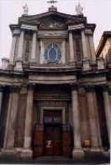  Piazza San Carlo  At the southern end of Piazza San Carlo sits the church of San Carlo. Built in 1619 on behalf of Duke Carlo Emanuele I to honour the Bishop of Milan whom he'd met in his youth. The octagonal domed bell tower was added later in 1779 whilst the façade dates from 1834 and was built by Ferdinando Caronesi. Inside there is a unique central aisle with two bays with cross vaults and two chapels on either side. The sister chapel of Saint Cristina stands close by.
Galleria Sabauda  - Contact:  - +39 011 440 6903  http://www.galleriasabauda.beniculturali.it/  - Via Accademia delle Scienze 6  - Palazzo dell'Accademia delle Scienze  Located within the Palazzo dell'Accademia delle Scienze, the Galleria Sabauda was established by 1832 King Carlo Alberto in 1832. Some 28 years later the Galleria was handed over to the State by Victor Emmanuel II and now contains a fine collection of paintings including the royal art collections amassed by the House of Savoy. There is work by local Piemontese artists and from other Italian schools such as Lombard, Venetian, and Emilian as well as the prestigious paintings from the Flemish, Dutch, and Northern Schools. | Palazzo Madama 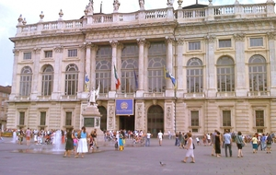  - Contact: +39 011 443 3501  - http://www.palazzomadamatorino.it/  - Piazza Castello  Full € 12,00  Reduced € 10,00  Free entry for minors (under 18 years of age) and other categories  Free admission on the first Wednesday of each month  Ticket prices could change during temporary exhibitions  Palazzo Madama is situated in the centre of Piazza Castello, with its facade facing Via Garibaldi. It takes its name from the two Royal Dames who lived here, Maria Cristina and Giovanna Battista. During past centuries, it was the home of the Savoy family, as well as the site of the signing of important treaties, and the seat of the Italian Senate when Turin was the country's capital. Today it houses the Antica Museum of Art (MUSEO CIVICO DI ARTE ANTICA). Its historical date is somewhat difficult to determine because it has been continually reconstructed throughout its history. The oldest part is the Roman Porta Pretoria. The back of the building dates to a thirteenth century castle which can still be seen in the two towers situated at each corners. The typically baroque facade was built in the seventeenth century by the architect Filippo Juvarra. The internal staircase is also attributed to him and is one of the best examples of the Piedmontese baroque style.
The Porticos  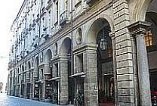  Via Roma  Contact:  tel: +39 011 535 181  Turin is a city made for walking, planned by the Romans on a grid pattern, the centre of the city is easy to negotiate and you hardly need to use a map to find your way around. There are some 18 km of porticoes, built by the Royal House of Savoy in the 18th century for its family and courtiers, to walk in the shade in summer and protected from the rain and snow in winter. Start in Piazza Castello and stroll down Via Roma, from Piazza Vittorio Veneto walk up Via Po, from Piazza Solferino walk down to Piazza Castello, visit a museum, do some shopping have a coffee, all under the famous porticoes. | GAM - Galleria Civica d'Arte Moderna e Contemporanea  Via Magenta, 31 10128 Torino - Italy  gam@fondazionetorinomusei.it  • Monday closed  • from Tuesday to Sunday 10.00 am -6.00 pm  Ticket office closes one hour before  ENTRANCE TICKETS TO THE GAM  Entire € 10,00  Reduced € 8,00  Free entrance on the first Tuesday of every month (excluded public holiday). Free entrance with Abbonamento Musei and Torino Cards.  Dedicated to Italian art of the 19th and 20th C., this large collection of paintings and sculptures focuses especially on the Piemontese artistic milieu. You will find, for example, the largest collection of works by Antonio Fontanesi (1818-1882), famous for his landscapes that bathe in a diffused light, of a rich and dense palette. The evolution of art is illustrated by G. Balla, F. Casporati, the Milanese Novecento group, the metaphysical paintings of Ferrare ( Carrà, De Chirico), the Roman school (Scipione, Maffei), the Group of Six from Turin (Boswell, Chessa, Galante, Levi, Menzio and Paolucci), and continues on to the most recent experiments of informal art and the Arte Povera. Finally, there is a section dedicated to Italian and international artistic production of the last thirty years of the last century. A remarkable panoramic view of modern and contemporary art.
Piazza San Carlo  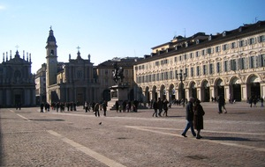  One of Italy's most stunning and beautiful squares, known locally as Turin's drawing room. Built in the mid 17th century and designed by Carlo di Castellamonte, perfectly laid out, porticoed and elegantly proportioned. At the square's southern end lie two churches, on the left, Santa Cristina, on the right, San Carlo, whilst in the centre stands a statue of Emmanuel Filbert, sculpted by Carlo Marocchetti in 1838, known as "El Caval 'd Brons" (The Bronze Horse). The square bisects Via Roma and makes the perfect place to stop for a coffee or apertivo after all that sightseeing and shopping. | Caffè Torino 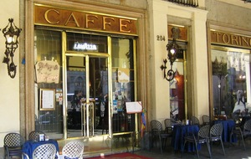  - Contact: +39 (0) 11 54 51 18  - http://www.caffe-torino.it/  - Piazza San Carlo, 204  One of the city's grandest cafés and most elegant meeting places, located in the beautiful Piazza San Carlo, known locally as 'Turin's drawing room'. Caffé Torino opened in 1903 and moved to its present location in the 1930's during the rebuiding of Via Roma. A favourite haunt of actors, poets and politicians, Cesare Pavese and Alcide De Gasperi were regulars, as were Brigitte Bardot and Ava Gardener. Caffé Torino is decorated with a heady mixture of cream and pistachio, glinting mirrors and sparkling chandeliers plus a belle epoque winding staircase. Famous quotations from international literary history adorn the walls and one above the bar pays homage to coffee: "dolce come l'amore, puro come un angelo, caldo come l'inferno". The atmosphere is definitely elegant but relaxed. In fair weather sitting at one of the outdoor tables, covered by 17th century porticoes, is a must. Between 18:00 and 21:00 you can snack off a fabulous selection of dishes and platters laid out along the bar for around 7 €. Don't forget to look out for the bull embedded in the pavement just outside, standing on his balls could bring you luck!
Basilica della Consolata  - Contact: +39 011 483 6111  - Via Maria Adelaide  Construction on this church began in 1679 under Guarino Guarini. The foundations were laid on the site where the church of Saint Andrea previously stood with its hexagonal presbytery. After the death of Guarini, Juvarra designed the dome upon which Bortoloni's fresco was painted. The 11th century Romanesque tower belonged to the previous church and now sits on the right hand side of the Basilica's facade. The church is decorated with many valuable marbles, most of which were votive offerings. The impressive marble floor is one of the main talking points of this church. Next to the Basilica della Consolata stands a 25 meter high dedicatory column. A statue of the virgin Mary was placed on top in 1835 as a thank you to the Madonna for keeping at bay the dreaded plague which devastated Europe that year. | Al Bicerin 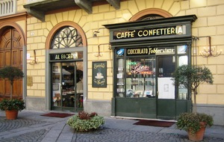  - Contact:  - +39 (0) 11 43 69 325 http://www.bicerin.it/  - Piazza della Consolata, 5  Located in Turin's atmospheric quadrilatero Romano, Turin's oldest and smallest café has barely changed since it opened in 1763. Frequented by Cavour, Dumas and Puccini, this establishment soon became very popular with the aristocracy. The minute interior has only eight marbled-topped tables and the original counter still stands as solid as ever whilst three dozen multi-coloured sweet jars perch on the shelves behind. It is the original home of the 'Bicerin'. An exquisite hot drink, with three layers, one espresso, one chocolate and one fresh cream in secret amounts, served in a tall glass so you can admire the fusion of colours and the aroma. Preferably sipped after mass at the Sanctuary of the Consolata just across the piazza, this is a truly Torinese ritual and not be missed on any account.
Museo della Sindone  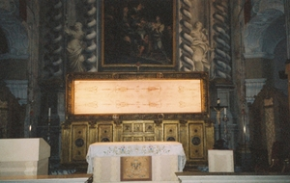  - Contact:  - +39 011 436 5832  - http://www.sindone.org  - Via San Domenico 28  The Museo della Sindone in an enchanting place in the downstairs of the baroque church of Holy Shroud, offers a multimedia journey, with interactive points, through the holiest relics of Christianity. Found here is also a photographic copy of the Shroud of Turin, taken straight after the fire of the cathedral in April 1997. | The Bull in Piazza San Carlo  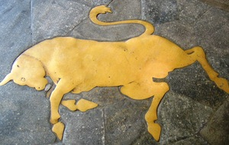  - Contact:  - +39 011 535 181  - Piazza San Carlo  Although the reasons why are obscure, the city has always been symbolized by a bull, but whatever the origin of the association, it must have had a positive value. This is the case with the bull in Piazza San Carlo. It is said that to tread on its horns, or even better its genitals, will bring great fortune. The only thing is that it must be done accidentally. And for this reason, you will not be told in what part of the square the bull is to be found, hoping that you will tread on him by accident!
Castello del Valentino  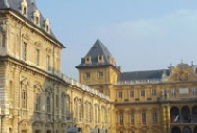  Corso Massimo d'Azeglio  Contact:  tel: +39 011 53 5181 (Tourist Information)  http://www.visitatorino.com/castello_valentino.htm  The ancient castle was bought by Duke Emmanuel Philibert of Savoy on the advice of Andrea Palladio. The nameValentino, first mentioned in 1275, seems to derive from a saint called Valentine whose relics were venerated in a church which stood nearby.  A cutaway drawing of the palace.  The current structure is due to Princess Christine Marie of France(1606–1663), wife of Victor Amadeus I, who dwelt here from 1630. Architect Carlo di Castellamonte renovated the construction substantially, with the help of his son Amedeo. Works started around 1633 and lasted until 1660.  It has a horseshoe shape, with four round towers at each angle, and a wide inner court with a marble pavement. The ceilings of the false upper floors are clearly in transalpino(i.e. French) style. The façade sports a huge coat of arms of the House of Savoy.  Minor modifications were made in the early nineteenth century; at this time, too, much of the seventeenth-century furniture was carried off by French troops. For the next half century the palace was more or less abandoned and fell into a state of disrepair. Renovations were carried out in 1860 when it was selected as the seat of the engineering faculty of Turin; it has been further restored in recent years.  Today it is the central building of the Architecture faculty of the Polytechnic University of Turin.  The Orto Botanico dell'Università di Torino, a historic botanical garden in the castle grounds. | Museo Egizio  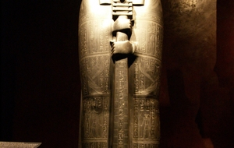  http://www.museoegizio.it/en/info/  OPENING HOURS  Mon: 09.00/14.00  Tue-Sun: 09.00/18.30  ADDRESS  Via Accademia delle Scienze 6, 10123 Torino  INFO & BOOKINGS  Tel. +39 011 44 06 903  info@museitorino.it  FULL PRICE € 15,00  REDUCED PRICE #1 Age 15 to 18 licensed journalists € 11,00  REDUCED PRICE #2 Age 6 to 14 € 1,00  REDUCED PRICE FOR SCHOOLS #1 Student groups, age 6 to 14 + 2 educators (elementary and middle schools) € 1,00  REDUCED PRICE FOR SCHOOLS #2 Student groups + 2 educators (high schools) € 4,00  Second only to the museum in Cairo, the Museo Egizio was founded in 1924. From then, the museum has expanded and now holds over 30,000 pieces, many of which are discoveries from the Italian Archeological Mission in the last century. 5000 years of art, religion, and daily life in the time of the Pharaohs are illustrated here through real treasures including the black statue of Ramses II, the book of death, the tomb of Kha and Merit, and the rocky temple of Ellesiya. Various cultural events happen here from time to time. Check website for more details.
Carignano Palace  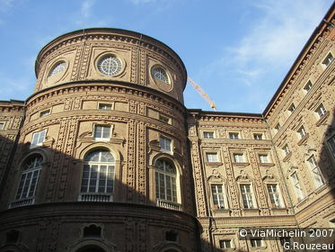  Piazza Carignano  http://www.palazzocarignano.it/  An unusually animated facade characterizes this palace built by Guarini, where the first King of Italy, Victor Emmanuel II, was born in 1820. So it naturally seemed the obvious place to install the National Musem of the Risorgimento, which houses a rich collection of documents witnessing the long and difficult march toward Italian Unification. You will visit the Sub-Alpine Parliament Hall, reminiscent of Cavour, Garibaldi, Verdi and Manzoni, and the Italian Parliament Hall. | Basilica di Superga  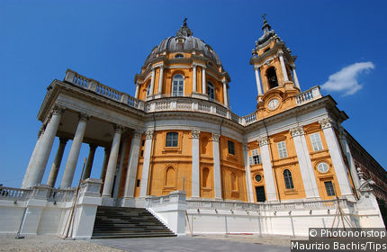  http://www.basilicadisuperga.com  Built on top of a hill that peaks at 670m, this imposing building, constructed between 1717 and 1731, is the masterpiece of architect Juvarra. The basilica has a circular layout and is topped with a dome, but its most remarkable feature is its monumental façade. Superga is first and foremost the pantheon of the Sardinian kings: the crypt houses the tombs of Victor Amadeus II, who commissioned the basilica, Charles Albert and numerous princes of the House of Savoy. The esplanade affords a fantastic view over Turin, the Po Valley and the Alps.
The church of Gran Madre di Dio 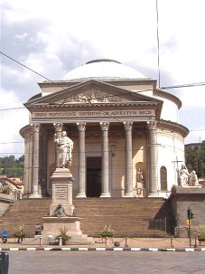  It is a Neoclassic-style church located in front of Piazza Vittorio Veneto, at the western side of the bridge Vittorio Emanuele I, in Turin, Italy.  The church was proposed in 1814 to celebrate the return of the King Victor Emmanuel I of Sardinia to the crown after the defeat of Napoleon. The architect was Ferdinando Bonsignore, whose project was chosen after a competition. Construction began in 1818, only to pause for nearly a decade, and restart in 1827, under the rule of Charles Felix of Sardinia. The church was inaugurated in 1831 under Charles Albert of Sardinia.  Flanking the entrance staircase are two statues representing Faith (with calyx) and Religion by Carlo Chelli. The tympanum of the church states: ORDO POPVLVSQVE TAVRINVS OB ADVENTVM REGIS, which can be translated as: (By the) Public Orders (dedicated) for the Return of the King. The church architecture recalls the Pantheon in Rome.  The steps of the Gran Madre appear twice in the 1969 film The Italian Job. | Reggia di VENARIA  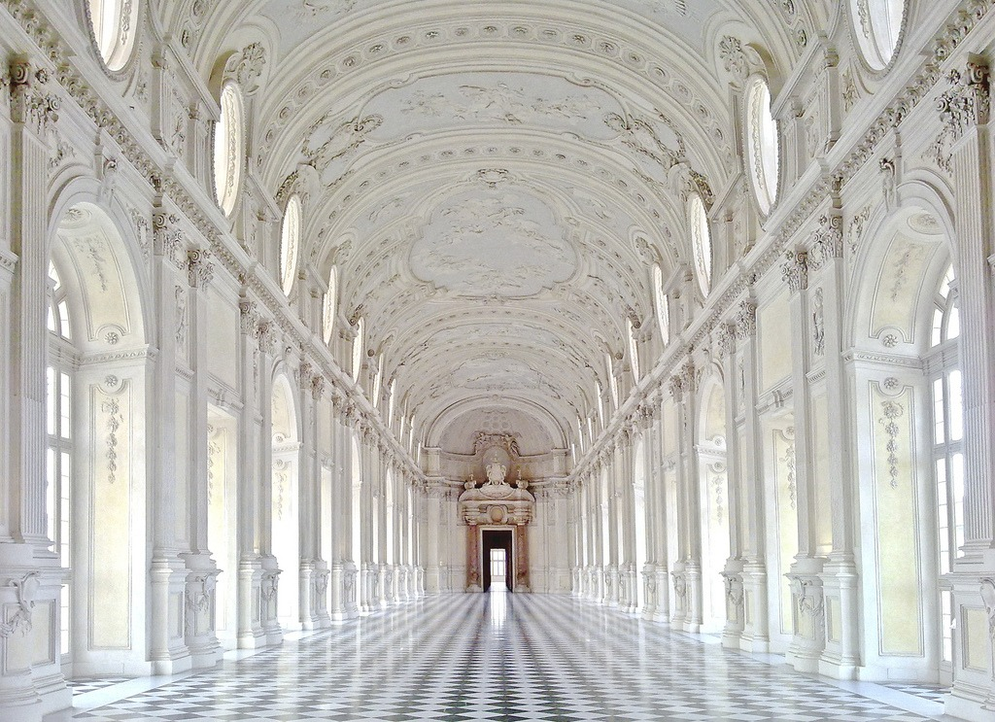  http://www.lavenaria.it/web/  Ticket offices close 1 hour before the times indicated below.  - Monday: closed (except public holidays - except Dec. 25 - same opening times as Sunday)  - Tuesday to Friday: from 9 to 17  - Saturday, Sunday and holidays: from 9 to 18.30  Reggia and Gardens  Full ticket 16 euros  Discounted (groups of at least 12 people, over 65, other categories eligible for discounts) 14 euros  Discounted age 6 to 21 (young visitors from 6 to 20 years of age) 10 euros  Children under the age of 6 and other categories eligible for free admission free  The Palace of Venaria (Italian: Reggia di Venaria Reale) is a former royal residence located in Venaria Reale, nearTurin, in Piedmont, northern Italy. It is one of the Residences of the Royal House of Savoy, included in the UNESCO Heritage List in 1997.  The Palace was designed and built from 1675 by Amedeo di Castellamonte, commissioned by duke Charles Emmanuel II, who needed a base for his hunting expeditions in the heathy hill country north of Turin. The name itself derives from Latin,Venatio Regia meaning "Royal Hunt".
From http://www.nileguide.com/destination/turin/trips

http://www.nileguide.com/destination/turin/things-to-do

Turin Trips and Itineraries
http://www.nileguide.com/destination/turin/trips

